Webs

Web 1.0: It refers to the first stage of the World Wild Web. It was entirely made of Web pages connected to the hyperlinks.
Example: It is that you only can read and you cant let coments

Web 2.0: Is the current state of online technology as it compares to the early days of the Web.
Example: there are blogs and facebook 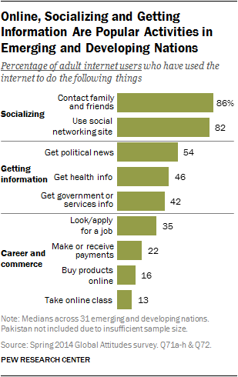

Web 3.0: Is slated to be the new paradigm in web interaction.Example: It is the new generation of the web interaction 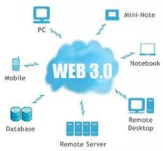
References:
Thursday, November 15, 2018
Tecnopedia
https://www.techopedia.com/definition/27960/web-10
Thursday, November 15, 2018
Walts .com
https://whatis.techtarget.com/definition/Web-20-or-Web-2
Thursday, November 15, 2018
Tecnopedia
https://www.techopedia.com/definition/4923/web-30

Images References
Blog Diseño Web
https://disenowebakus.net/world-wide-web-www.php
Monday, November 26, 2018

Evolution of Web
http://nickbaliguat.blogspot.com/
Monday, November 26, 2018

Pew Research Center
http://www.pewglobal.org/2015/03/19/internet-seen-as-positive-influence-on-education-but-negative-influence-on-morality-in-emerging-and-developing-nations/
Monday, November 26, 2018

